United Church of Clinton
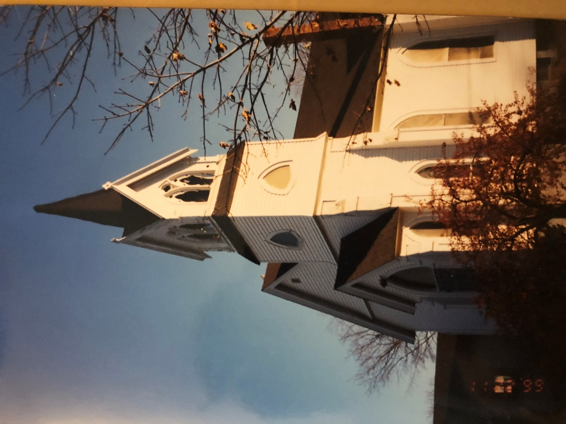

October 28, 2018 Worship - 10:00 am
Pastor, Rev. Lee Atherton Musician, Ilana Cady
Ministers, The People of God

“Live as people who are free, not using your freedom as a cover-up for evil, but living as servants of God. Honor everyone. Love the people.” 1 Peter 2:16

RINGING of the BOWL / TIME of CENTERING
Please use this time during the prelude in silent prayer and preparation for worship.

WELCOME and ANNOUNCEMENTS (Psalm 34)
*CALL to WORSHIP (please stand as you are able)
Leader: I will bless the Lord at all times; his praise shall continually be in my mouth.
People: My soul makes its boast in the Lord; let the humble hear and be glad.
Leader: O magnify the Lord with me, and let us exalt his name together.
People: O taste and see that the Lord is good, happy are those who take refuge in him.

*HYMN of PRAISE SUPPORTING HUMAN JUSTICE
“Open My Eyes, That I May See” #586
You are invited to bring your gifts to support our outreach and mission opportunities.

PRAYER of the DAY
God of Grace, when fear’s nightmares dissolve into morning wonder; when despair’s monsters hiding under our beds turn out to be hope’s dust bunnies, you restore our lives. Jesus of Justice, when you pick up those we trip as they try to meet you; when you gather the lonely into the widening circle of your heat, you help us to take heart. Spirit of Loveliness, when you bring us home from addiction’s neighborhoods; when you wipe the cheeks of all those who grieve rejection; when you sit by us holding our hands while we dangle our feet in still waters, you whisper words of life.

And we tell of what you do, God in Community, Holy in One, even as we pray as Jesus teaches us, “Our father who art in heaven, hallowed be thy name. Thy kingdom come. Thy will be done, on earth as it is in heaven. Give us this day our daily bread and forgive us our debts as we forgive our debtors. And lead us not into temptation, but deliver us from evil. For thine is the Kingdom, the Power, and the Glory forever. Amen.”

*GLORIA PATRI
Glory be to the Father, and to the Son, and to the Holy Ghost; As it was in the beginning, is now and ever shall be; world without end. Amen. Amen.

(you may be seated)

SCRIPTURE Mark 10:46-52 p.48
CHILDREN’S MESSAGE
*HYMN “The Summons”
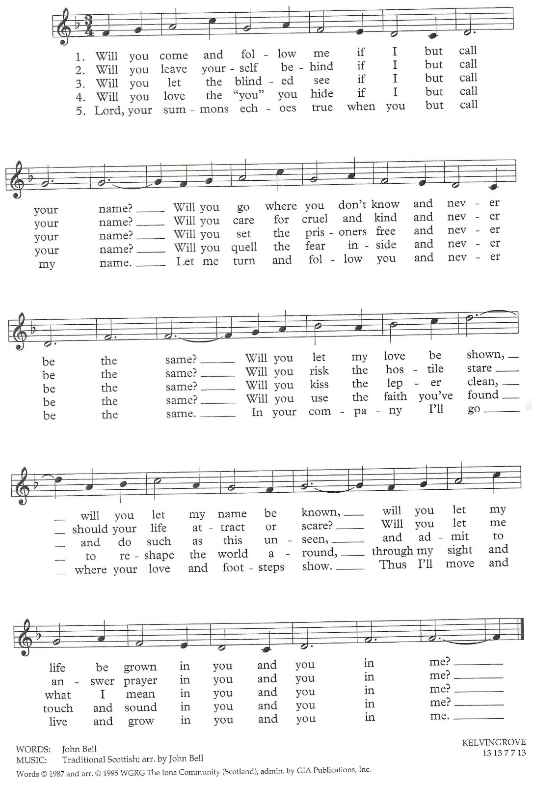

PRAYERS of CONFESSION and RESTORATION
We hear people crying out for justice, God of compassion, but tell them to be quiet so we can hear our favorite politicians. People stand by the side of the road with a sign reading ‘will work for hope,’ and we speed up to get past them. Some are tripped up by the struggles of life, and we wonder why they can’t pull themselves together. Have mercy on us, God whose tears mingle with those we have ignored. Help us answer as you beckon us to love all people.

PASSING the PEACE of CHRIST

In the spirit of worship, and abiding in Christ's love, let us turn to one another singing "Peace Be with You". Please be seated when the music ends.

SHARING OUR JOYS, CONCERNS, and GLIMPSES of GOD
You are invited to share your concern or celebration briefly so that all who wish will have time to share. Please consider the privacy of other’s information.
PASTOR’S PRAYER
PRAYER RESPONSE “Heal Me, Hands of Jesus” verse 1 #504
Heal me, hands of Jesus, and search out all my pain;
Restore my hope, remove my fear, and bring me peace again.

PRESENTING OUR GIFTS to GOD
HYMN of DEDICATION “My Life Flows On” #619
*SONG of PRAISE (#46 in Hymnal)
Praise God from whom all blessings flow. Praise God all creatures here below. Praise God above, ye heavenly host, Creator, Christ, and Holy Ghost. Amen.

*PRAYER of DEDICATION

Wow! Look what God does. Whatever we offer, large sums and pocket change, God uses it in amazing ways to bring all God’s children close. Receive our gifts in gratitude and faithfulness, O God. This we pray in Jesus’ name. Amen.
SCRIPTURE Job 42:1-6, 10-17 p.538
PASTOR’S MESSAGE

MUSICAL REFLECTION

*SENDING HYMN “Wonderful Words of Life” #323

BLESSING and SENDING FORTH

SUNG AMEN

BELL and POSTLUDE

Our worship has ended ~ Let our service begin!

New Joys and Concerns, Ongoing Prayers
- Justin Fillios – young adult struggling with life choices
- Chet Thompson, Jan Januska’s brother in law, recovering from surgery and CDIFF
- Jamie McNamara, recovering from a heart attack
- Jan Ganusko grieving Gloria’s death
- Kayla Morkert, struggling with mental health challenges
- Laura Garceau and her family, on the passing of her mom Daphe Schuler Friday morning.
Bobby and Lauren Fillios Bonnie Clark Justin Fillios
Bill Yacopucci Marj and Art Lamy Gloria Nillson
Bob Wheeler Carol and Steve Granger Larry Gilman, Sr
Tyler Bauman & Family Bill Cummins Dolly Duca

The Week (and month) Ahead
Today 10:00am Worship – Harvest Festival
11:30am Vitality Scouts
Monday – Saturday Pastor Lee on Vacation
Wednesday, October 31 Happy Halloweeen!! Be SAFE!
Saturday, November 3 Change your clocks!
Sunday, November 4 8:00am Worship Planning
9:15am Ensemble
10:00am Worship – Harvest Festival
After Worship Bake Sale

This Weeks Birthdays
31 - Pamela Dobeck 31 - Diamily Titus 31 - Courtney Kane 02 - Patrick Ruperto
Happenings at United Church
Pastor Lee answers: Are Christians really supposed to be celebrating Halloween? First let me say that whatever you hope the answer is, you’ll find an article or blog on line backing you up – whether you are Christian or not. I never put too much thought into this until my very conservative neighbors moved in. Before them, Auntie Jean and Uncle Roland lived there – Roland was one of Dad’s childhood friends and they built their homes next to each other. Uncle Roland was the best house to go trick or treating at when I was growing up. All the kids in the neighborhood went to his house even though the driveway was really long to get there. He gave out tennis balls and full-sized candy bars! And not just one but at least two or three. And then there were all the marketing goodies he brought home from his Board work. You could fill your whole pumpkin at his house! All the kids in the neighborhood went trick or treating – and as an adult I can look back at my Catholic friends, Christian friends, and others in the neighborhood who were likely Jewish and other faith traditions. No one didn’t go. When I was about 40 years old (still living there), someone new moved in and I was shocked when the Dad curtly answered “We don’t do that” when I asked what his kids would dress up as for Halloween. There are many verses in the Bible that suggest Halloween is NOT OK!

Dressed as Dracula or as devils, neighborhood children have or will be happily "trick or treating" in the United States and some other countries. But would it surprise you to know that "Halloween" (by that name) started out as a holy Christian celebration?
Hallow, in Old English, means "holy" or "sacred." Therefore, "Hallows' Eve," or "Halloween" simply means "the evening of holy persons" and refers to the evening before All Saints Day, which is November 1 on both Anglican and Catholic calendars. Halloween is a mixture of Celtic religious ideas and Christian martyrology. Somewhere in the halls of history “All Hallows Eve” got hijacked. What started as a day to prepare for All Saints Day became a spooky, evil, and candy-filled night. The word Halloween has nothing to do with pagan or evil beliefs. It comes from hallowed – which is Holy. Think of “Our Father, who art in heaven, hallowed be your name.”

So, yes, I believe there’s nothing wrong in celebrating a night of fun and laughter, tricks and treats. Just be sure to brush your teeth! And then remember All Saints Day.
Don’t forget Daylight Savings ends next Sunday at 2am. Let your clocks “fall behind” and enjoy your extra hour of sleep!

Bring your appetites for sweets next Sunday. Youth Council will bring their usual absolutely delicious desserts to raise funds for turkeys and fridge for those who might not otherwise have a nice Thanksgiving dinner.

Next Sunday, November 4th, we will celebrate All Saints Day, a time to remember all those who we have loved and who have died. For morning worship, you are invited to bring a photo or small item remembering your loved one. We will incorporate those into worship. At 5pm, we will hold our annual Night of Remembrance service beginning in the sanctuary. Dress warm for our time outside.
Pastor Lee will be on vacation this week. If you have an emergency or concern, please reach out to Laurelle in the office (978-365-9232) or to Pam Dobeck (978-815-0751) or Bob Lidstone (978-660-8739).

Want a head start on Sunday’s Scripture? Join our online Bible Study conversation at. https://www.facebook.com/groups/212011619443321/ [ Pastor Lee’s Bible Study] and join our Sunday morning Bible Study drop in group. Be sure to check our online calendar for dates of the drop in. http://www.clintonunitedchurch.org/archives/130

What do you Think? Have any ideas? Not seeing something you wish was here? A worship theme idea? Small group ministry? On-line workshop topic? A retreat? You name it – if you put your ideas and suggestions in the suggestion box on the table by the handicap bathroom we’ll do our best to make it happen.

Greeting our guests with an Extravagant Welcome: When we have visitors to our church, do you suppose they feel welcomed? Or do we make them feel EXTRAVAGANTLY WELCOMED? They say that a visitor to church makes up their mind in as quick as the first few minutes. One way we can help is to WEAR YOUR NAMETAG – at worship AND at coffee hour!

The German Christmas Market will be here before you know it! This is a huge fund-raiser and community awareness for our church and needs lots of helping hands to be successful. If you can help in any way – before or during; half an hour or lots of hours; at home or at church – be in touch with Dawn Sivert or leave a message at the office.

The Vision Statement of the United Church of Clinton

God’s people loving and serving God.

The Mission Statement of the United Church of Clinton

At the United Church of Clinton we seek to:
- Spread the word of God;
- Love God and our neighbors passionately;
- Provide Christian education to people of all ages;
- Work together in the local community and beyond by using our spiritual gifts in faithful service to those in need;
- Live and bear testimony to our faith by being an example of Christian living;
- Reach out to friends, families, and neighbors and invite them to join with us for reverent worship, heartfelt prayer, joyful music, and devoted celebration of the sacraments;
- Encourage and create a sense of love and belonging to God’s family.

THE UNITED CHURCH OF CLINTON
109 Haskell Avenue Clinton, Massachusetts 01510
Website: clintonunitedchurch.org E-Mail: cu@clintonunitedchurch.org
Pastor’s E-Mail: Lee@CoachRev.com Church Office: 978-365-9232

