United Church of Clinton
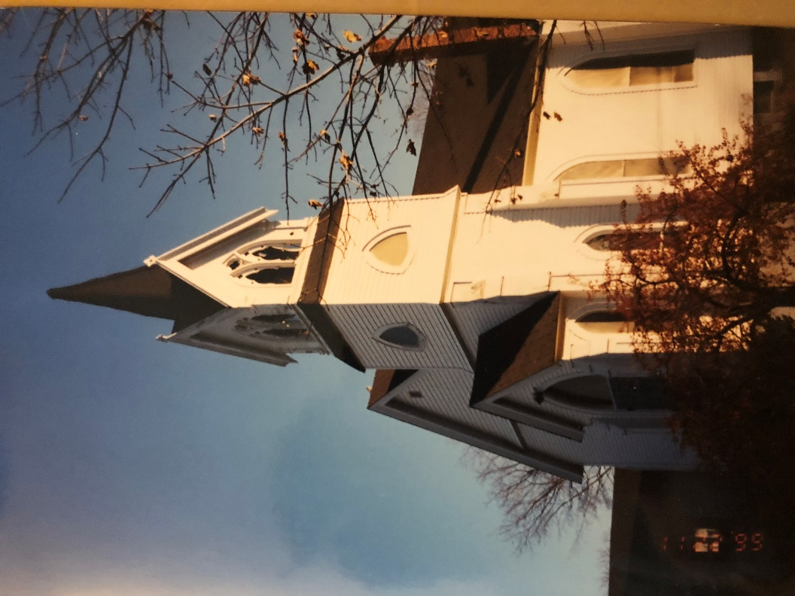

Story Telling Sunday

October 14, 2018 Worship - 10:00 am
Pastor, Rev. Lee Atherton Musician, Ilana Cody
Ministers, The People of God

“Finally, beloved, whatever is true, whatever is honorable, whatever is just, whatever is pure, whatever is pleasing, whatever is commendable, if there is excellence and if there is anything worthy of praise, think about these things.” Philippians 4.8
RINGING of the BOWL / TIME of CENTERING
Please use this time during the prelude in silent prayer and preparation for worship.

WELCOME and ANNOUNCEMENTS

*CALL to WORSHIP Steven Shakespeare, St Bride’s
(please stand as you are able)
Leader: We rise to the dawning of life;
People: Countless beings sing the hymn of creation.
Leader: We feel the spirit moving in all things;
People: The earth, sky and sea bring us healing.
Leader: We touch the humming lines of connection;
People: The web of all things sparkles with energy.

*HYMN of PRAISE SUPPORTING HUMAN JUSTICE “We Gather Together” #276
You are invited to bring your gifts to support our outreach and mission opportunities.

PRAYER of the DAY (please join in reading the bold portion)
May the Spirit of creation, healing and connection bless and hold this space, this time, this being-together. And may all that we bring and all that we are find a welcome in the silence. (Silence)

Through the spaces of our city, public and private, sacred and profane, neglected and contested, divided and united, commercial and communal, the Spirit makes its exile way:
Seeking a home,
Seeking a face,
Seeking a listening ear.

Spirit of God, be with us here.

Through the spaces of our lives confused and radiant, hurting and healing, anxious and confident, ashamed and proud, beautiful and broken, the Spirit walks the inner path:
Seeking the truth,
Seeking the soul,
Seeking the child within.
Spirit of God be with us here.

Because all is yours, even us, God in Community, Holy in One, we pray as we are taught, “Our father who art in heaven, hallowed be thy name. Thy kingdom come. Thy will be done, on earth as it is in heaven. Give us this day our daily bread and forgive us our debts as we forgive our debtors. And lead us not into temptation, but deliver us from evil. For thine is the Kingdom, the Power, and the Glory forever. Amen.”
*GLORIA PATRI
Glory be to the Father, and to the Son, and to the Holy Ghost; As it was in the beginning, is now and ever shall be; world without end. Amen. Amen.

(you may be seated)

SCRIPTURE Psalm 78:1-4, 67-72 (responsive)
Leader: Listen, dear friends, to God’s truth, bend your ears to what I tell you. I’m chewing on the morsel of a proverb.
People: I’ll let you in on the sweet old truths, stories we heard from our fathers, counsel we learned at our mother’s knee.
Leader: We’re not keeping this to ourselves, we’re passing it along to the next generation –
People: God’s fame and fortune, the marvelous things he has done.
Leader: He disqualified Joseph as leader, and told Ephraim he didn’t have what it takes,
People: And chose the Tribe of Judah instead, Mount Zion, which he loves so much.
Leader: He built his sanctuary there, resplendent, solid and lasting as the earth itself.
People: Then he chose David, his servant, handpicked him from his work in the sheep pens. One day he was caring for ewes and their lambs, the next day God had him shepherding
Leader: Jacob, his people Israel, his prize possession.
People: His good heart made him a good shepherd, he guided the people wisely and well.

CHILDREN’S MESSAGE
*HYMN “Sometimes God Begins a Project” #507

PRAYERS of CONFESSION and RESTORATION
We stand before you, Saving God, stripped of our pretensions and pride, for nothing we do or say can be hidden from you. You hear the angry words we mumble to ourselves; you sift through the rubble of hurts we’ve caused; you see how we stumble, weighed down by all that 'stuff' which keeps us from following your way. We stand before you, Holy Grace. As you empty our hands of that wealth of unneeded things we cling so tightly to, fill them with your grace and hope. As we let go of all which might hold us back, give us the trust to follow Jesus.

PASSING the PEACE of CHRIST

In the spirit of worship, and abiding in Christ's love, let us turn to one another singing "Peace Be with You". Please be seated when the music ends.

SHARING OUR JOYS, CONCERNS, and GLIMPSES of GOD
You are invited to share your concern or celebration briefly so that all who wish will have time to share. Please consider the privacy of other’s information.
PASTOR’S PRAYER
PRAYER RESPONSE “Heal Me, Hands of Jesus” verse 1 #504
Heal me, hands of Jesus, and search out all my pain;
Restore my hope, remove my fear, and bring me peace again.

PRESENTING OUR GIFTS to GOD
HYMN of DEDICATION “In The Garden” #227
*SONG of PRAISE (#46 in Hymnal)
Praise God from whom all blessings flow. Praise God all creatures here below. Praise God above, ye heavenly host, Creator, Christ, and Holy Ghost. Amen.

*PRAYER of DEDICATION

You are the Great Provider, the Giver of all gifts; your love the only true currency.
Thank you for putting money into our hands, and so we freely offer it back to you,
for use in your service. We do this in the name of Jesus, Amen.
SCRIPTURE
PASTOR’S MESSAGE
OUR STORIES
HYMN “I Come to The Garden”
And he walks with me, and he talks with me, and he tells me I am his own
And the joy we share, as we tarry there, none other has ever known.
MOMENT OF MUSICAL REFLECTION

*SENDING HYMN “What Does the Lord Require of You” #661

BLESSING and SENDING FORTH

May the light of God illumine the heart of your soul.

May the flame of Christ kindle you to love.

May the fire of the Sprit free you to live this day, tonight and for ever. Amen.

SUNG AMEN

BELL and POSTLUDE

Our worship has ended ~ Let our service begin!

New Joys and Concerns, Ongoing Prayers
- Mary Ellen Matthew, Gloria Parkinson, Janet Lamy, Dawn and Perry Sivert, who have recently experienced the death of someone dear to them.
- Family and Friends of Carl O’Donnell who died last week. A celebration of his life will be held here at United Church tomorrow morning at 10. Calling hours are this afternoon from 4-7pm and McNally Funeral Home.
- Bonnie Clark whose husband died recently and who is struggling with health issues.
Bobby and Lauren Fillios
Bill Yacopucci Rachael and Kevin III Gloria Nillson
Bob Wheeler Carol and Steve Granger Larry Gilman, Sr
Tyler Bauman & Family Bill Cummins Dolly Duca Cathy Darazio
Scott Maynard Marj and Art Lamy Charlotte Conway
The Week (and month) Ahead
Sunday, October 14 10:00am Worship
11:15am Bake Sale
11:15am Fall Clean Up
Thursday, October 18 3:00pm Stewardship
Sunday, October 21 9:15am Ensemble
10:00am Worship
11:00am Servants in Faith
3:00pm Pastor Lee’s Installation
Happenings at United Church
Newsletter Deadline: Please submit your items to the office by October 24th.

Want a head start on Sunday’s Scripture? Join our online Bible Study conversation at. https://www.facebook.com/groups/212011619443321/ [ Pastor Lee’s Bible Study] and join our Sunday morning Bible Study drop in group. Be sure to check our online calendar for dates of the drop in. http://www.clintonunitedchurch.org/archives/130
CONGRATULATIONS!!! To Clinton Presbyterian Church who celebrated their 125th anniversary in September. Please take a moment to sign the card for them that is on the table to the left just after entering Marquart Hall.
What do you Think? Have any ideas? Not seeing something you wish was here? A worship theme idea? Small group ministry? On-line workshop topic? A retreat? You name it – if you put your ideas and suggestions in the suggestion box on the table by the handicap bathroom we’ll do our best to make it happen.

Greeting our guests with an Extravagant Welcome: They say that a visitor to church makes up their mind in as quick as the first few minutes. It is so important that we welcome them as soon as we see them – not overpowering, but letting them know we see them. The deacons are preparing Visitor Bags with some fun goodies in them. Also important is helping them get to know us. So PLEASE – WEAR YOUR NAMETAG – at worship AND at coffee hour!

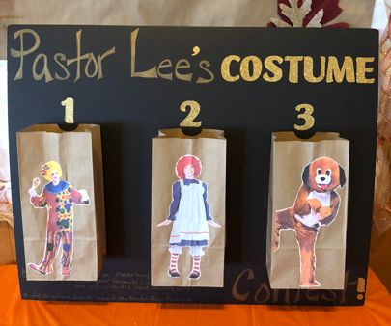
The German Christmas Market will be here before you know it! This amazing event is a huge fundraiser and community awareness for our church and needs lots of helping hands to be successful. If you can help in any way – before or during; half an hour or lots of hours; at home or at church – be in touch with Dawn Sivert or leave a message at the office.
Which costume do you want to see Pastor Lee in?! You’ll find this display in Marquart hall where you can vote which costume she will wear on October 28th. Our Sunday School children chose these three and the winner will be whichever bag gets the most votes by $! Funds raised will benefit the Berlin Food Pantry Thanksgiving Turkey collection.

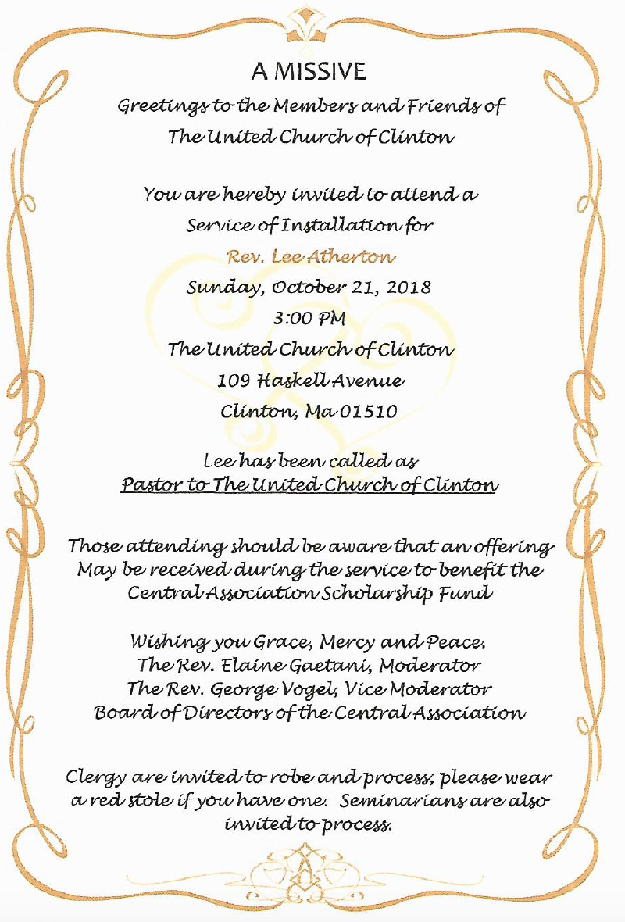
ur people.

The Vision Statement of the United Church of Clinton

God’s people loving and serving God.

The Mission Statement of the United Church of Clinton

At the United Church of Clinton we seek to:
- Spread the word of God;
- Love God and our neighbors passionately;
- Provide Christian education to people of all ages;
- Work together in the local community and beyond by using our spiritual gifts in faithful service to those in need;
- Live and bear testimony to our faith by being an example of Christian living;
- Reach out to friends, families, and neighbors and invite them to join with us for reverent worship, heartfelt prayer, joyful music, and devoted celebration of the sacraments;
- Encourage and create a sense of love and belonging to God’s family.

THE UNITED CHURCH OF CLINTON
109 Haskell Avenue Clinton, Massachusetts 01510
Website: clintonunitedchurch.org E-Mail: cu@clintonunitedchurch.org
Pastor’s E-Mail: Lee@CoachRev.com Church Office: 978-365-9232

